**Alfred 3 - QuitFocus Workflow**

This workflow allows the user to **quit** any of the active apps **or** to **focus** on any of the active and visible windows.

Initial Keyword: win

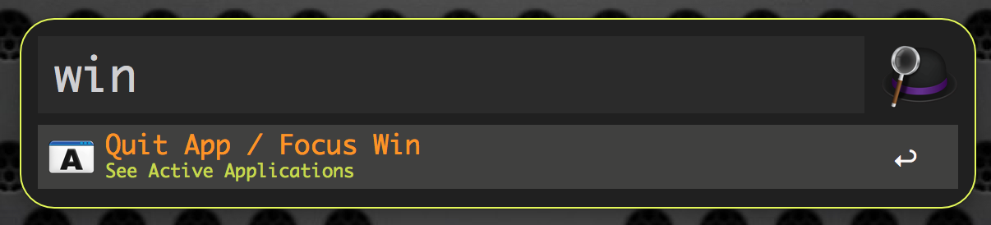

1. Select an active application.

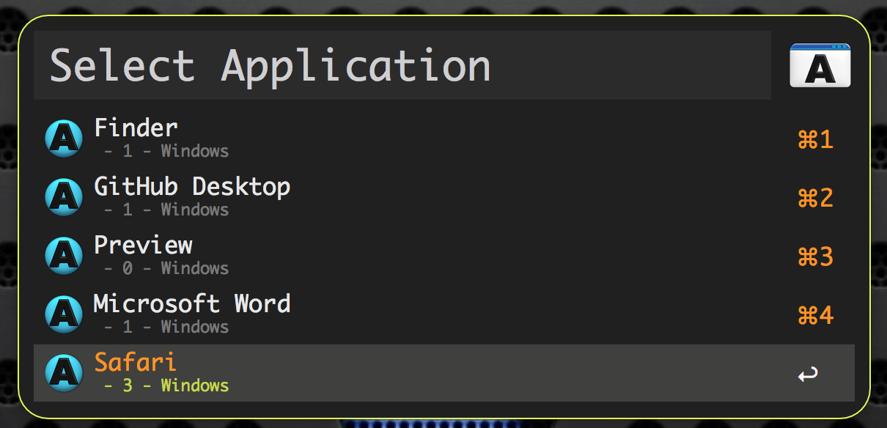

**Note:** The number shown under the application name is the number of active windows of that application.

1. Select “Quit” to quit the application or “Focus” to see the list of the active windows

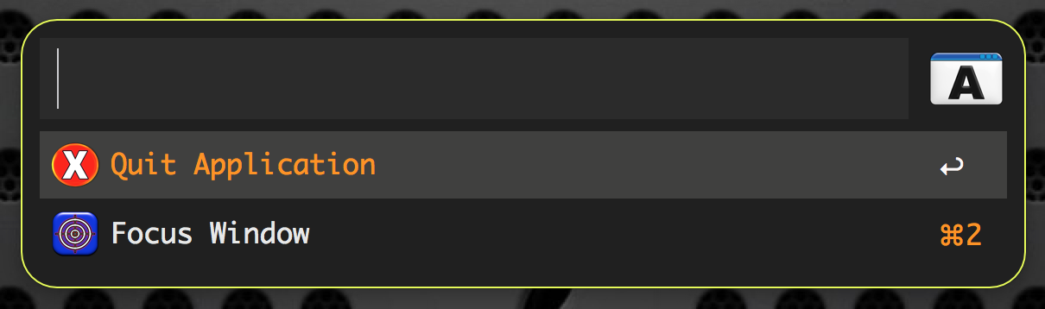

3)

If “Quit”: The application will quit and you will receive a notification.

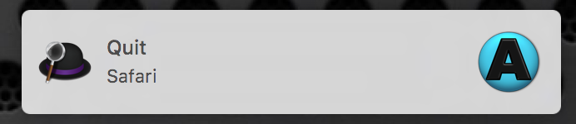

if “Focus”: You will see a list of the active windows.

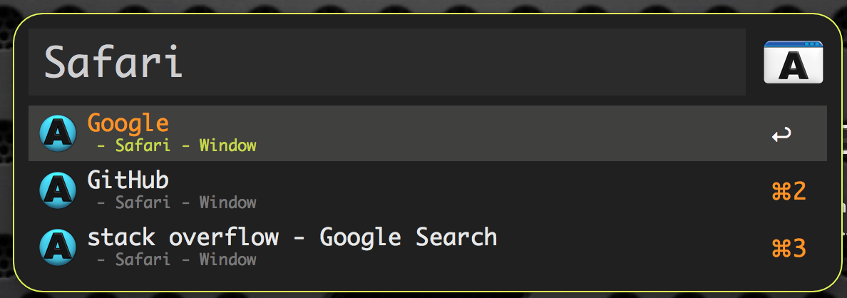

Once you select a window from the list then that window will become the front active window with focus.